Wall Mounted 10" Color Touch Screen
10. 1" LCD Screen

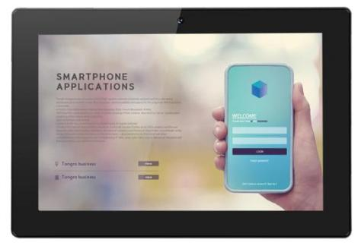
User Manual

Contents

Notes of Importance..........................................................................................................2
Features............................................................................................................................. 3
Package Contents..............................................................................................................4
POE Connect.................................................................................................................... 4
Android OS Home Screen................................................................................................ 5
Install APP......................................................................................................................... 7
Uninstall APP.................................................................................................................... 8
Factory Reset..................................................................................................................... 9
Specifications.................................................................................................................. 10

1

Notes of Importance
1)The equipment is for indoor use only.
2)To reduce the risk of ﬁres or electric shock, do not expose the equipment to rain or moisture.
3)Do not block the ventilation holes on the back of equipment at any time. 4)Do not subject the equipment to severe shocking
5)Prevent any foreign matter falling int the external slot.
6)Do not open the case of the equipment. There is a risk of electric shock,and there are no user serviceable parts inside. Opening the case will void your warranty.

2

Features

◆ 10.1" LCD Screen, 800*1280
◆ RK3399 Dual Core A72 1.8GHz+ Quad core A53 1.4GHz
◆ Mali-T864 GPU
◆ Android 7.1.2/ 8 / 9
◆ 10-point Capacitive touch screen
◆ WiFi 2.4GHz & 5GHz
◆ Front Camera 2.0M/P
◆ Bluetooth 4.2
◆ POE ( POE compliance with IEEE 802.3at/af)
◆ 1 x USB 3.0 host
◆ 1 x USB 2.0 host
◆ 1 x USB type C
◆ 2 x 2W Speaker
◆ 1 x RJ45Ethernet port
◆ 1 x DC input

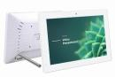
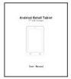
Package Contents
Please make sure all of the following are present when you unpack your Android Tablets.
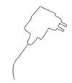

10. 1” Android tablet Power adapter User manual

POE connect

POE Router 10. 1” POE tablet
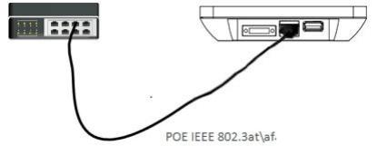

Please make sure the POE Router support IEEE 802.at\af standard

5
Install
1) Insert the power lead into the DC socket, and then insert the other end into the power socket.
2) The Equipment will automatically power on
3) Screen will show starting logo.
4) Waiting for about 25 seconds and enter into main interface.

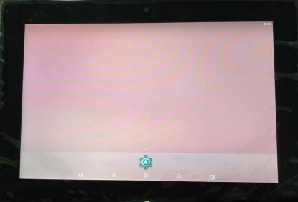

5) In the main interface, Use mouse to click icon to go to APPS menu screen.
6) Click the apps icon to enter into apps click the “RETURN” icon, return to previous, page click the “HOME” icon return to the main interface.

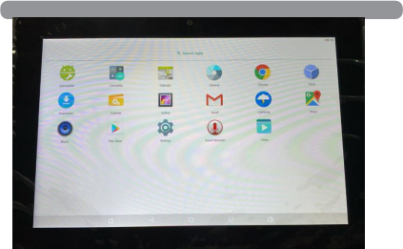
6
Install
1) Copy the ﬁle ofAPK format to your device or SD card.
2) Click the that in APPS, then you will enter into the ‘APK Installer’, select ‘install’, as the following picture:
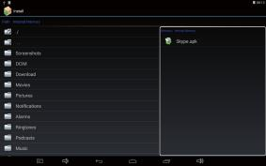
3) Click the APK which you want to install, as the following pictures:

7
Install
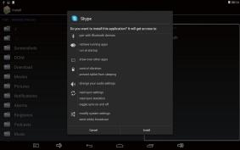
4) After installing the APK, you can click the APK icon in the apps to enjoy the application.

Uninstall

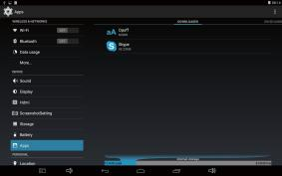

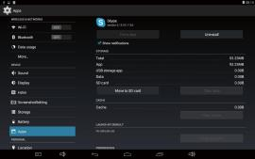

9
Factory
Ifyour device has been contracted the virus, or worked unexpectedly by installing
‘reset tablet’ and ‘erase everything’, as the following picture:

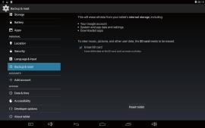

10

No. | Item | SPEC
1 | CPU | RK3399 Dual Core A72 1.8GHz+ Quad core A53  1 4GHz
2 | O/S | Android 7. 1.2/8. 1/9
3 | DRAM | 4GB
4 | Memory | EMMC, 16GB /32GB
5 | LCD | 10. 1” IPS touch screen
6 | LCD Resolution | 10. 1",800x1280
7 | Touch screen | Capacitive touch panel
8 | WiFi | 802. 11b/g/n/ac
9 | Ethernet | 10M/100M Ethernet
10 | Bluetooth | Bluetooth 4.2
11 | Camera | 2.0M/P
12 | Video format | MPEG1;MPEG2;MPEG4;UHD,H.265,H.264,RV,VC- 1,VP8
13 | Audio format | MP2,MP3,AAC etc.
14 | DC input | DC 12V/2A input
16 | interfaces | USB 2.0*1,USB 3.0*1, USB type C *1,  DC*1,earphone*1,SD card*1
17 | VESA | 75mmx75mm
18 | POE | POE IEEE802.3at\af
19 | Power consumption | 20W(max)
20  21 | The dimensions  Color | 260.54mm(L)*178.54mm(W)*25.50mm(H)  Black / White

11
Common Problems And Countermeasures

1. Can't open the machine
Solutions: may connectors, connect the charger after 10 minutes to boot.
2. In the touch screen have no reaction when charging or automatically jump to the other interface.
Solution: The connection is not the factory configuration chargers may cause bad touch, please use the factory configuration when charging.
3. After open the WiFi, not be able to connect to the router
Solution: May the WiFi password input error, please enter the password correctly.

4. In the abnormal operation after crash, lag
Solution: Insert the hole and Long press the reset button to 10 seconds to turn it off, then restart will be back to normal.

