USER MANUAL

HDMI Extender By Coaxial

Full HD up to 80 channel @ 500m

Model No：HDTVHDEX009M1

HDTV Supply, Inc.

Enjoy the vivid world!

REMARK
Manufacturer does not make any commitment to update the information contained herein.
Dear customer

Thank you for purchasing this product. For optimum performance and safety, please read these instructions carefully before connecting, operating or adjusting this product. Please keep this manual for future reference.

The products are designed to make your A/V device use more convenient, comfortable, productive and cost-efficient.

The HDMI coaxial extender can do digital coding processing for HDMI signal with DTV technology.
The product adopts RF modulation technology characteristic to transmit the Multiple RF signal through
one common coaxial cable (SYV-75/RG59) for long distance transmission without amplification. The
receiver can restore the high-definition video signal and transmit it to the TV or monitor. By adding
DTV network mixer at the RF cable, you can easily achieve many kinds of transmission mode, e.g.
signal split, switch and matrix.

Our devices offer solutions for noise, space and security concerns, data center control, information distribution, conference room presentation, school and corporate training environments.

INTRODUCTION
FEATURES：
- Contains a transmitter (TX) and a receiver (RX). The TX supports a HDMI input and the RX supports a HDMI output.
- Support HDMI resolution up to 1080P/60Hz.
- Transmission distance up to 500 meters by SYV-75-5 coaxial cable and no need amplification.
- Adding digital TV network mixer in RF cable, can easily achieve many kinds of transmission mode, e.g. signal split, switching and matrix.
- Support 80 channels for option; frequency ranges 139MHz~950MHz.
- Products using the broadcast signal transmission mode, only one line can transmit 48 channels of high-definition video signal at the same time.
- The use of digital TV communication protocol, anti interference and error correction capability is very strong.
- Installs in minutes. Analog monitor system upgrade to HD systems can continue to use the original connector and cable.
- DC5V/1A power adapter
PACKAGE CONTENTS:

1. Extender TX unit 1pcs
2. Extender RX unit 1pcs
3. AC power adapter 2pcs
4. User manual 1pcs

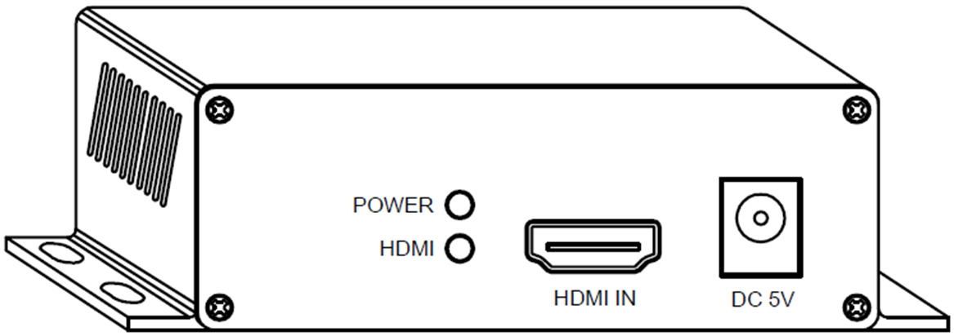
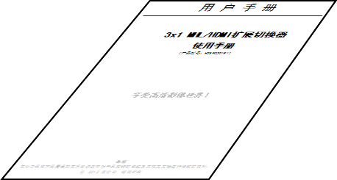
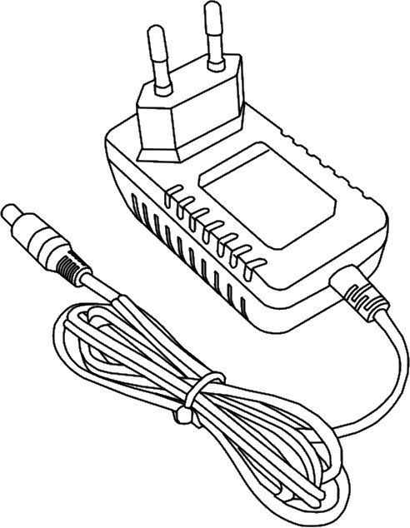
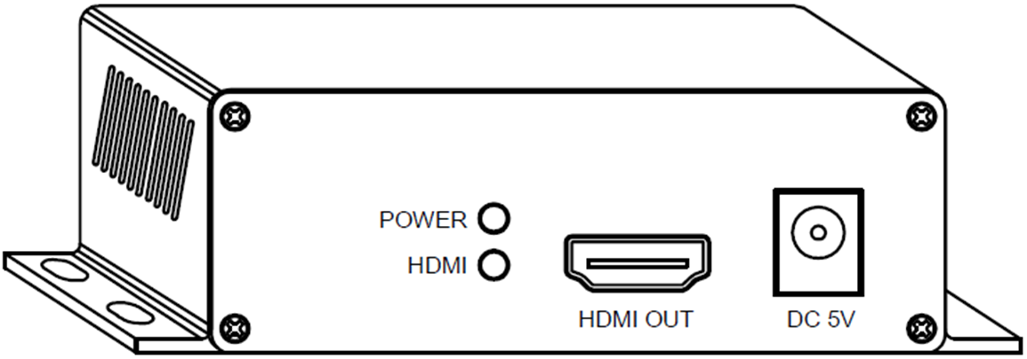

FEATURES OF THE INTERFACE:
Transmitter (TX)
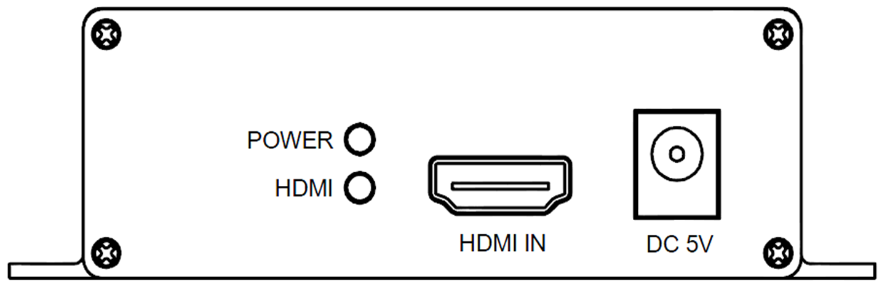
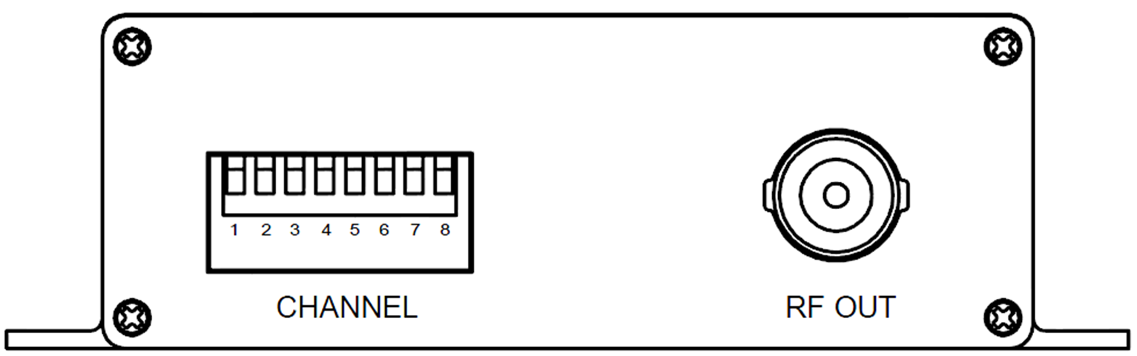

FIG.1 TX Front Panel View FIG.2 TX Rear Panel View

PWR LED: POWER ON/OFF indicator
HDMI LED: HDMI input indicator
DC5V: 5V DC in jack
HDMI IN: HDMI signal input
CHANNEL: Channel selection switch
RF OUT: RF signal output

Receiver (RX)
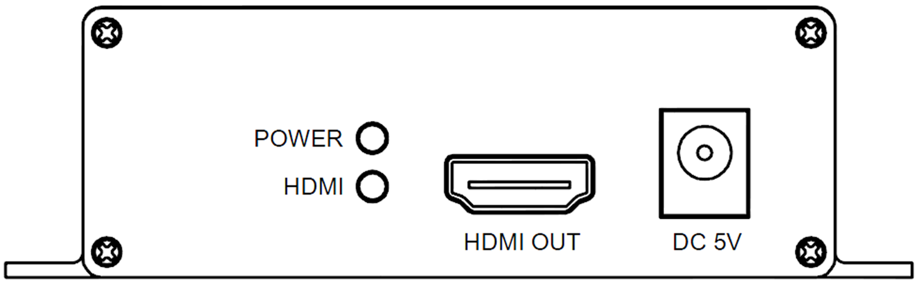
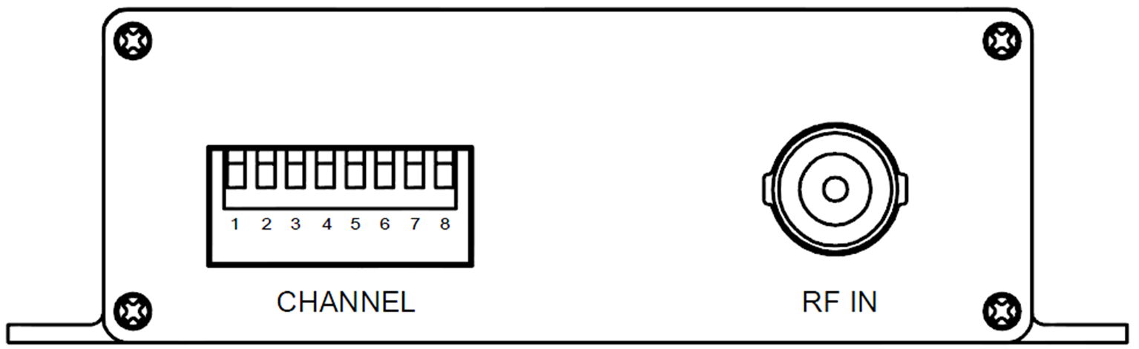

FIG.3 RX Front Panel View FIG.4 RX Rear Panel View

PWR LED: POWER ON/OFF indicator
HDMI LED: HDMI output indicator
DC5V: 5V DC in jack
CHANNEL: Channel selection switch
RF IN: RF signal input

HDMI OUT: HDMI signal output

OPERATIONG AND CONNECTION:
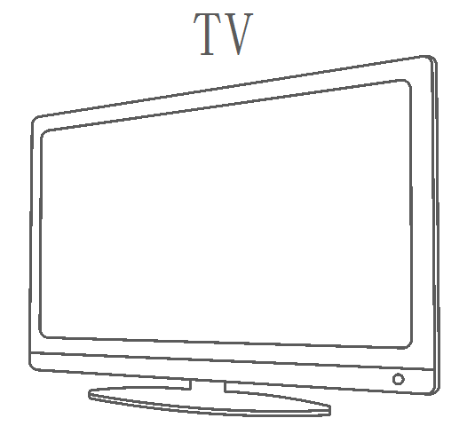
Ⅰ. Point to point mode

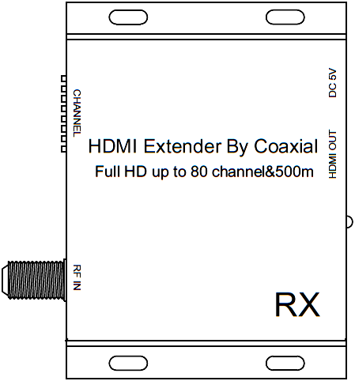
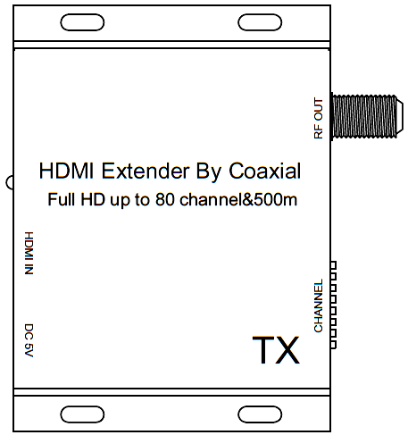
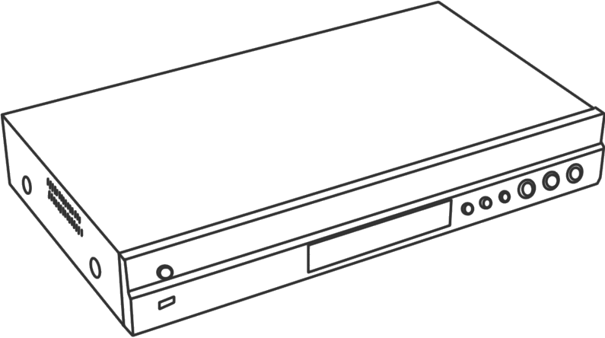
Coaxial cable
Coaxial cable
Coaxial cable
TV/Monitor
DVD/BD/STB
HDMI cable
HDMI cable
HDMI cable
TX
RX

FIG.5 CONNECTION DIAGRAM
- Connect one SYV-75/RG59 coaxial cable from TX RF OUT into the RX RF IN.
- Connect one HDMI cable from a DVD/BD player into the HDMI input port of TX.
- Connect one HDMI cable from TV/Monitor into the HDMI output port of RX.
- Set same ID to Channel switch of TX and RX (Detailed setting method reference behind the table).
- Connect 5V power supply to the TX&RX, and inserted into the power socket.

Ⅱ. Splitter mode
HDMI
cable
HDMI
cable
TV/Monitor
RX

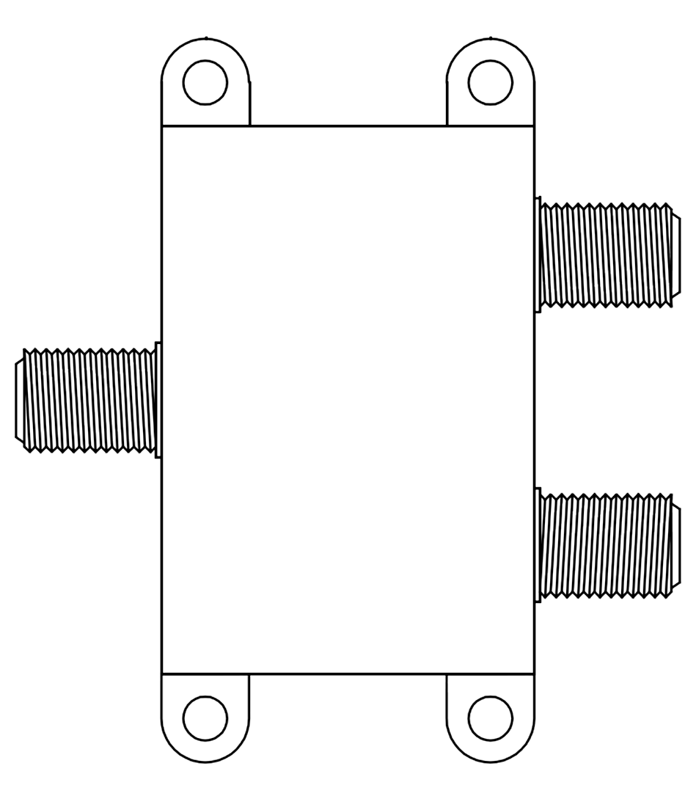
Coaxial cable
DVD/BD/STB
TX
DTV MIXER
TV/Monitor
RX

FIG.6 SPLITTER CONNECTION DIAGRAM
- Connect one SYV-75/RG59 coaxial cable from TX RF OUT into the input port of DTV mixer.
- Connect SYV-75/RG59 coaxial cables from RX RF IN into the output ports of DTV mixer.
- Connect one HDMI cable from a DVD/BD player into the HDMI input port of TX.
- Connect HDMI cables from TV/Monitor into the HDMI output port of RX.
- Set same ID to Channel switch of TX and RX (Detailed setting method reference behind the table).
- Connect 5V power supply to the TX&RX, and inserted into the power socket.

Ⅲ. Matrix mode
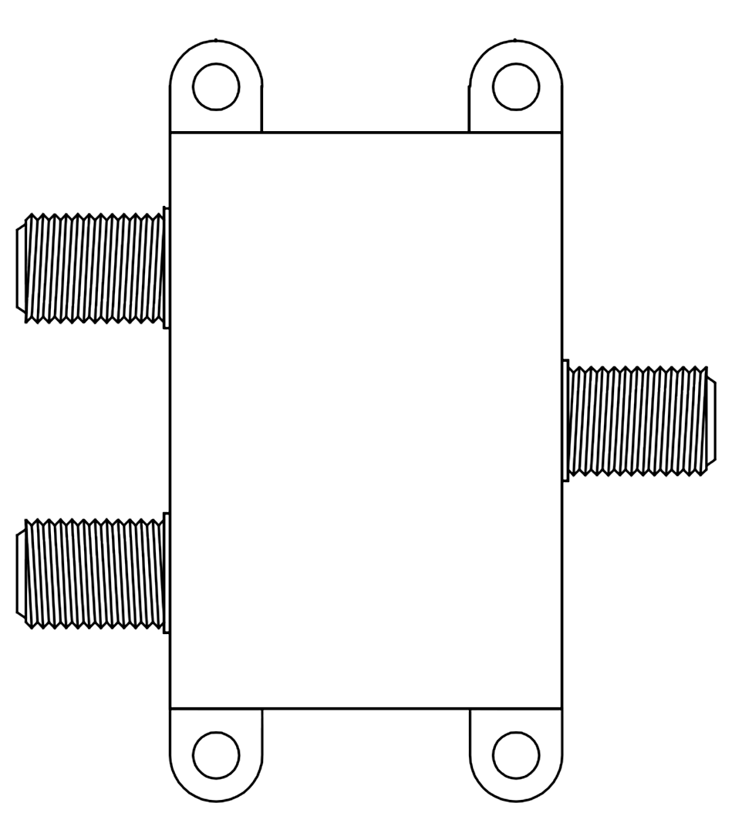
DVD/BD/STB
HDMI
cable
TV/Monitor
Coaxial cable
Coaxial cable
Coaxial cable
HDMI
cable
HDMI
cable
RX
TX
Coaxial cable
Coaxial cable
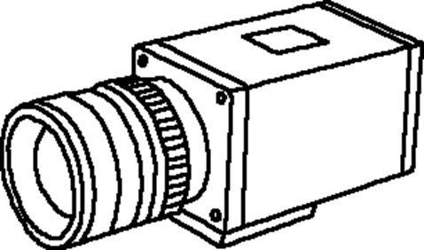
HD camera
HDMI
cable
TV/Monitor
RX
DTV Mixer
TX

FIG.7 MATRIX CONNECTION DIAGRAM
- Connect SYV-75/RG59 coaxial cables from TX RF OUT into the output ports of DTV mixer.
- Connect SYV-75/RG59 coaxial cables from RX RF IN into the output ports of DTV mixer.
- Connect input ports of two DTV mixers with one SYV-75/RG59 coaxial cable.
- Connect HDMI cables from DVD/BD player into the HDMI input port of TX.
- Connect HDMI cables from TV/Monitor into the HDMI output port of RX.
- The need for communication with the TX and RX set to the same channel.
- Connect 5V power supply to the TX&RX, and inserted into the power socket.
Notes:
1. In normal conditions, transmission distance up to 500 meters by SYV-75-5 coaxial cable and no
need amplification. For the high-frequency RF signal haves signal attenuation, signal strength will
become weakened after adding DTV network mixer and multi output.
2. If the signal frequency is high, the transmission attenuation is greater. So choose low channel for
long-distance transmission.
3. When the transmission distance is short (less than 100 meters), because the signal is too strong, RX may protect and display "NO SIGNAL" to TV. So now you should choose high channel or adding attenuator in coaxial cable for the signal attenuation.
4. With the channel set and frequency values refer to the table below, and channel selection switch setting method is as follows:
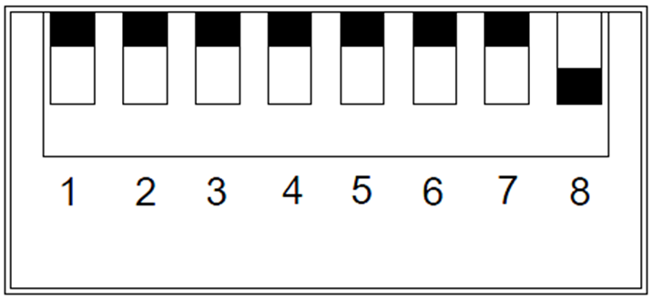
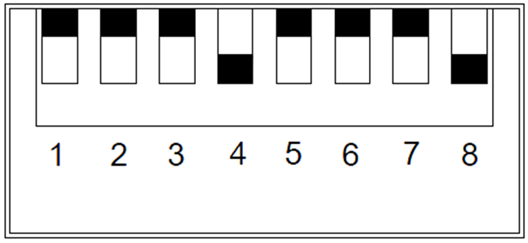

e.g.1 CH1（0000 0001） e.g.2 CH11（0001 0001）
Channel set and frequency reference table
Channel  ID | Switch Setting  （12345678） | Frequency（MHz） | BW  （MHz） |  | Channel  ID | Switch Setting  （12345678） | Frequency（MHz） | BW  （MHz）
1 | 0000 0001 | 142.5 | 7 |  | 41 | 0100 0001 | 634 | 8
2 | 0000 0010 | 149.5 | 7 |  | 42 | 0100 0010 | 642 | 8
3 | 0000 0011 | 156.5 | 7 |  | 43 | 0100 0011 | 650 | 8
4 | 0000 0100 | 163.5 | 7 |  | 44 | 0100 0100 | 658 | 8
5 | 0000 0101 | 177.5 | 7 |  | 45 | 0100 0101 | 666 | 8
6 | 0000 0110 | 184.5 | 7 |  | 46 | 0100 0110 | 674 | 8
7 | 0000 0111 | 191.5 | 7 |  | 47 | 0100 0111 | 682 | 8
8 | 0000 1000 | 198.5 | 7 |  | 48 | 0100 1000 | 690 | 8
9 | 0000 1001 | 205.5 | 7 |  | 49 | 0100 1001 | 698 | 8
10 | 0001 0000 | 212.5 | 7 |  | 50 | 0101 0000 | 706 | 8
11 | 0001 0001 | 219.5 | 7 |  | 51 | 0101 0001 | 714 | 8
12 | 0001 0010 | 226.5 | 7 |  | 52 | 0101 0010 | 722 | 8
13 | 0001 0011 | 410 | 8 |  | 53 | 0101 0011 | 730 | 8
14 | 0001 0100 | 418 | 8 |  | 54 | 0101 0100 | 738 | 8
15 | 0001 0101 | 426 | 8 |  | 55 | 0101 0101 | 746 | 8
16 | 0001 0110 | 434 | 8 |  | 56 | 0101 0110 | 754 | 8
17 | 0001 0111 | 442 | 8 |  | 57 | 0101 0111 | 762 | 8
18 | 0001 1000 | 450 | 8 |  | 58 | 0101 1000 | 770 | 8
19 | 0001 1001 | 458 | 8 |  | 59 | 0101 1001 | 778 | 8
20 | 0010 0000 | 466 | 8 |  | 60 | 0110 0000 | 786 | 8
21 | 0010 0001 | 474 | 8 |  | 61 | 0110 0001 | 794 | 8
22 | 0010 0010 | 482 | 8 |  | 62 | 0110 0010 | 802 | 8
23 | 0010 0011 | 490 | 8 |  | 63 | 0110 0011 | 810 | 8
24 | 0010 0100 | 498 | 8 |  | 64 | 0110 0100 | 818 | 8
25 | 0010 0101 | 506 | 8 |  | 65 | 0110 0101 | 826 | 8
26 | 0010 0110 | 514 | 8 |  | 66 | 0110 0110 | 834 | 8
27 | 0010 0111 | 522 | 8 |  | 67 | 0110 0111 | 842 | 8
28 | 0010 1000 | 530 | 8 |  | 68 | 0110 1000 | 850 | 8
29 | 0010 1001 | 538 | 8 |  | 69 | 0110 1001 | 858 | 8
30 | 0011 0000 | 546 | 8 |  | 70 | 0111 0000 | 866 | 8
31 | 0011 0001 | 554 | 8 |  | 71 | 0111 0001 | 874 | 8
32 | 0011 0010 | 562 | 8 |  | 72 | 0111 0010 | 882 | 8
33 | 0011 0011 | 570 | 8 |  | 73 | 0111 0011 | 890 | 8
34 | 0011 0100 | 578 | 8 |  | 74 | 0111 0100 | 898 | 8
35 | 0011 0101 | 586 | 8 |  | 75 | 0111 0101 | 906 | 8
36 | 0011 0110 | 594 | 8 |  | 76 | 0111 0110 | 915 | 8
37 | 0011 0111 | 602 | 8 |  | 77 | 0111 0111 | 924 | 8
38 | 0011 1000 | 610 | 8 |  | 78 | 0111 1000 | 930 | 8
39 | 0011 1001 | 618 | 8 |  | 79 | 0111 1001 | 938 | 8
40 | 0100 0000 | 626 | 8 |  | 80 | 1000 0000 | 946 | 8
Switch setting note: 0-dial switch to the up, 1-dial switch to the down. In fact, the switch 8 bit code
equals to the binary code of channel ID.
SPECIFICATIONS: HDEX009M1
HDMI resolution ……………………………………..24/50/60fs/1080p/1080i/720p/576p/576i/480p/480i
HDMI Audio Format……………………………………………………………………………………..LPCM
HDMI Max bandwidth………………………………………………………….……………………...225MHz
HDMI Max baud rate…………………….………………….………………….……………………6.75Gbps
Input/Output TMDS signal ………….……………………………….……………….0.5~1.5Volts p-p(TTL)
Input/Output DDC signal ……………………………………………..……………………. 5Volts p-p (TTL)
RF frequency range…………………………………………………………………………...139～950 MHz
RF Channel B/W…………………………………………………………………………..................7/8 MHz
The number of Channel…………………………………………………………………............................80
RF Output power…………………………………………………………………..............................-6dBm
RF Connector type…………………………………………………………………The imperial F type/BNC
Coaxial cable Characteristic impedance…………………………………………………………………75Ω
RF transmission distance………………………………………≤500m SYV-75-5 coaxial standard cable
HDMI output cable distance………………………………………...≤15m AWG26 HDMI standard cable
TX Max working current …………………………………………………………….……….…….…. 650Ma
RX Max working current …………………………………………………………….……….…….…. 500mA
Power adapter format Input ……......….….…….…….…….…. AC 100V～240V 50HZ/60Hz, DC5V/1A
Operating Temperature range ……..…………….……………………………………………. -10 to +45℃
Storage Temperature range……………………………………………………………………. -20 to +60℃
Operating Humidity range ………………………….….……….……….10 to 90%RH (No Condensation)
Storage Humidity range………………………….….……….……………5 to 95%RH (No Condensation)
Case Dimension (L x W x H) ………………………………….…………………………….94x74x28 (mm)
Weight …….…………………………….………………………………………….………………..…… 240g

Notes:
Please use the machine as the instruction listed to keep the long use lifetime of the machine.
- The machine should be placed at the spot far from the Damp, High-Temperature, Dusty, Erosive, and oxidative environment.
- All parts will be free from the strong shake, hit, fall.
- Touching the power adaptor with the wet hands is prohibited.
- Please hold the power adaptor head and do not pull the power cord when cut off from the socket.
- Please turn the power off when the machines not used for long time.
- Please do not open the cover and do not touch the inside parts.
- Please use the original factory power adaptor.
FAQ:
Before power on, please check the connection line carefully. And make sure that all interfaces are normally connected. The common trouble shooting way shows below:
No. | Problem Description | Solutions
1 | Non-Power-Connected | 1. Check if the power adaptor head is truly and correctly inserted the power socket.  2. Check the power if it is in on status.
2 | Display “No SIGNAL” to TV | 1. Confirm the coaxial cables are intact and reliable connection.  2. Confirm the length of coaxial cable is too short. When the transmission distance is short (less than 100 meters), you should choose high channel or adding attenuator in coaxial cable for the signal attenuation.  3. Confirm the TX and RX channel settings should be the same  4. Check the cable quality. ( Recommend use SYV-75/RG59 coaxial standard cable)
3 | Display “SIGNAL LOSS” to TV | 1. Confirm the HDMI cable of TX is intact and reliable connection.  2. Check the signal source is power on and output normal.  3. Check the HDMI cable quality.
4 | Display “RESOLUTION NOT SUPPORT” to TV | 1. Check the signal source output resolution, may be set too high.  2.Confirm whether to support the signal resolution of TV
5 | Image mosaic/ Abnormal Picture | 1. Confirm the coaxial cables are intact and reliable connection.  2. Confirm the length of coaxial cable is too short or long.  3. Device EDID read error, please reboot.  4. Nearby signal interference, proposals to change the other channel
6 | Abnormal sound | 1. Check the signal source output audio format is LPCM. Audio  output options of signal source should be set to "Auto" or "LPCM"  2. Device EDID read error, please reboot.
HDTV Supply, Inc.
3835-R East Thousand Oaks Blvd
Unit 295
Westlake Village, CA 91362
(800) 841-9238
(805) 277-1870 Direct
(805) 371-4070 FAX - Tech Support
(805) 435-2623 FAX for orders, RMA info and availability
WEB: www.HDTVSupply.com

