HDTV SUPPLY, INC

User Manual

SDI/HD-SDI 1 to 2 Distribution
Amplifier

HDTVND1102BD

NOTE: The casing design is subject to change without notice.
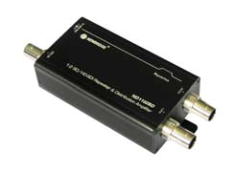

This HDMVND1102BD SD/HD-SDI Distribution Amplifier is a 1 to 2 repeater and distribution amplifier with Re-clocking function. It receives one SDI input and perfectly duplicates it. Then it re-transmits two SDI outputs for real time multi-viewing. It is a reliable video device splitting a SDI or HD-SDI video source to two HD-SDI or SD-SDI display at the same time and takes one input then re-clocks and equalizes the signal and distributes it to two identical outputs.

Features ..

• SDI Standard: HD-SDI and SD-SDI
• Data Rates: 270Mbps/1.485 Gbps
• Signal Type: SMPTE 292M, SMPTE 259M
• Two separately buffered outputs
• Cable equalization (Belden 1694A) retiming and signal
• Re-clocking function capability – unlimited repeater connection
• Dual color LED indication of power and video signal link
• Pass all ancillary data
• 5V~24V DC

HDTVND1102BD-ND1202G

R201210-V2.1
Please read the Manual before attempting to use this product.

Specifications and appearance are subject to change without notice.

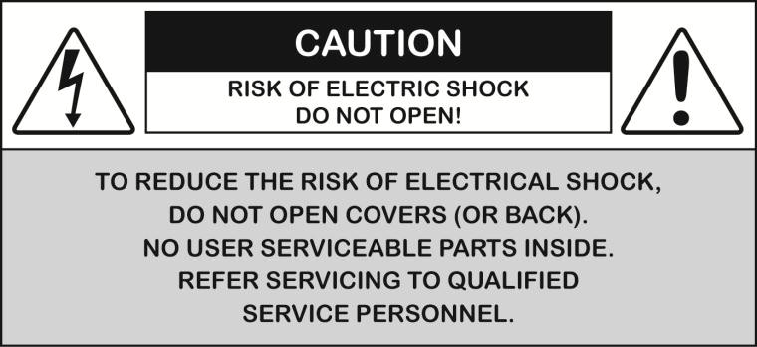

Disposal of Old Electrical & Electronic Equipment (Applicable in the European Union and other European countries with separate collection systems).


This symbol on the product or on its packaging indicates that this product shall not be
treated as household waste. Instead it shall be handed over to the applicable collection point for the recycling of electrical and electronic equipment. By ensuring this product is
disposed of correctly, you will help prevent potential negative consequences for the environment and human health, which could otherwise be caused by inappropriate waste handling of this product. The recycling of materials will help to conserve natural resources.
For more detailed information about recycling of this product, please contact your local city office, your household waste disposal service or the shop where you purchased the product.

Caution ..


1. Handle this product with care
Avoid any shock or bumping of the product. Improper handling could damage the
product. Do not handle the unit with wet hands. Provide proper ventilation and air circulation and do not use near water.
2. Requires a proper operating environment
This product is not waterproof and is designed for indoor use. The allowable temperature
range for operation of this product is between 0°C~40°C / 32°F~104°F.
3. Check the power source voltage
The power source voltage should be within the specified range. (Product must meet the specifications).
4. Objects and liquid entry
Never push objects of any kind into this product as this may touch dangerous voltage points of short out parts that could result in a fire or electric shock. Never spill any kind
of liquid on the product.
5. Cleaning
Do not use liquid or aerosol cleaners to clean this unit. Always unplug the power to the
device before cleaning.
6. Servicing
Do not attempt to service this product by yourself as opening or removing covers may expose you to dangerous voltage or other hazard s. Refer all service to qualified servicing personnel.

Package Contents ..

1. One (1) SD/HD/ 1 to 2 Distribution Amplifier
2. One (1) User Manual
3. One (1) AC Adapter

1. 2. 3.
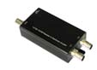
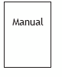

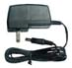

For any returns, please include all components listed above with original packaging in Resalable Condition. Absolutely No Returns will be accepted if any component is missing/damaged.

Application Diagram ..

* The distance depends on the quality of the SDI signal from the HD camera source and also the
Coax Cable & Connector

ND1102BD 1 to 2 Distribution Amplifier (HDTVND1102BD as example)

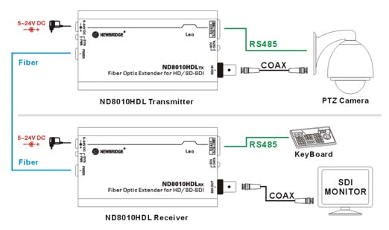

See page 8 for Important Notes about Cable and Connector for SDI HD Camera
Parts & Functions ..
HDTVND1102BD 1:2 SD/HD-SDI Repeater & Distribution Amplifier

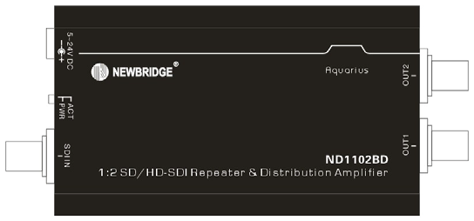

HDTVND1202BD 1:2 SD/HD-SDI Repeater & Distribution Amplifier

Name | Color | Status | Description
ACT-SDI | Green | ON | SDI signal is active status.
ACT-SDI | Green | OFF | SDI signal is inactive status.
PWR | Green | ON | Power source has been connected.
PWR | Green | OFF | Power source hasn’t been connected.

Hardware Installation ..

1. To open the box, then checking the quality, model no. and quantity of the equipment and accessories according to the picking list, if there were any questions, just feel free to contact us or the local distributors.
2. To check the power supply configuration, if it were DC input, just connects with the correct voltage according to the power supply input requirements. To connect AC/DC Adapter to the alternating current power supply socket.
3. Connect a camera or other devices equipped with HD/SD-SDI outputs to the
HDTVND1202G input.
4. Connect devices equipped with HD/SD-SDI inputs (e.g. monitors or video processors) to the ND1202G outputs.
5. Plug power adapter cable into power jack.

Te chnical Specifications
Model | ND1102BD
Re-clocking Function | Yes
SDI Standards | SD-SDI, HD-SDI
HD/SD-SDI Detection | Auto
Supported Protocols | SMPTE 259M SMPTE 292M
V ideo Bandwidth | 1.485Gbps
Data Rates | 270 / 1483 / 1485 Mbps

V ideo Support | [3G]1080p50/59.94/60  [HD] 720p50/59.94/60, 1035i50/59.94/60, 1080i50/59.94/60,  1080p24/30  [SD] NTSC@59.94Hz, PAL@50Hz
SDI Signal Type | SMPTE-292M, SMPTE-259M,
Output Impedance | 75 ohms
Cable Equalization | HD-SDI up to 200m/500ft  SD-SDI up to 300m/1000ft
Audio Support | Yes
RP-918 Pathological  Patterns | Immune
PCB Stack-up | 4-layer board  [impedance control -- differential 100 ohms;
Input | 1x BNC
Output | 2x BNC
BNC Connector | 75 ohms inter-locked socket
Eye Pattern  Characteristics | Amplitude: Within 800mV ±3%  (<10%)  Rise overshoot: Less than 2% (<10%) Fall overshoot: Less than  2% (<10%) Long time jitter: 0.195  UI (<1.0 UI)
Power Adapter | 5V~24V DC
Power Consumption | 2~4 Watts
Relative Humidity | 20~90% RH (no condensation)
Dimension | 113*48*25mm
`
Key Components ..
Components Made in USA for this product:
Name of Component | Manufacturer
Multi-Rate SDI Adaptive Cable | Mindspeed & Gennum
Multi-Rate SDI Automatic Reclocker | Mindspeed & Gennum
Multi-Rate Dual Slew-Rate Cable | Mindspeed & Gennum & National
Data Communication IC | MAXIM
Components Made in China for this product:
Name of Component | Manufacturer
DC/DC Converter | Richtek

*Key components are listed by the manufacturer and are subject to change without notice
EyeDiagram ..

SD-SDI Mode
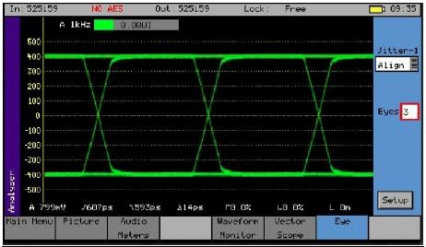

HD-SDI Mode

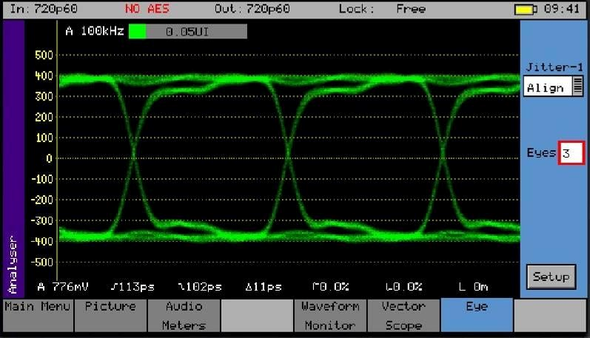
IMPORTANT NOTE: Cable & Connector for SDI HD Camera
In order to achieve the Best Quality and LongRange coax cable run of up to 200m /
600ft, you will need:
1. Good Quality Cable: We suggest using RG6 Belden 1694A Low Loss Serial Digital coax cable because RG6 cables have better grounding than RG59 cables. RG6 is for Digital Signal and RG59 is for Analog Signal.
2. Good Quality BNC Connectors: Contact Plating Gold plated pins provide exceptional conductivity.
3. Good Quality Installation: Do not over cut the braid because it will affect the grounding. The image will have lines and noise.

Bare opper

Jacket Braid Shielding

Limited Warranty ..

LIMITED ONE (1) YEAR WARRANTY AND EXCLUSIONS
Manufacturer warrants to the original consumer purchaser and not for the benefit of anyone else that this product at the time of its sale by Manufacturer is free of defects in materials and workmanship under normal and proper use for one (1) year from the purchase date. Manufacturer's only obligation is to correct such defects by repair or replacement, at its option, if within such one (1) year period the product is returned prepaid, with proof of purchase date, and a description of the problem. This warrant excludes and there is disclaimed liability for
labor for removal of this product or reinstallation. This warranty is voided if this product is installed improperly or in an improper environment, overloaded, misused, opened, abused, or altered in any manner, or is not used under normal operating conditions or not in accordance with any labels or instructions. There are no other implied warranties of any kind, including merchantability and fitness or a particular purpose, but if any implied warranty is required by the applicable jurisdiction, the duration of any such implied warrant, including merchantability and fitness of or a particular purpose, is limited to one (1) year.
Manufacturer is not liable for incidental, indirect, special, or consequential damages, including without limitation, damage to, or loss of use of, any equipment, loss sales or
profits or delay or failure to perform this warranty obligation. The remedies, provided therein are the exclusive remedies under this warranty, whether based on contract, tort or


otherwise.




HDTVND1202BD/HDTVND1202G
MADE IN CHINA

201210-V2.18

