DVI & Audio to HDMI Converter
ITEM NO.: HDTVDH01

This device provide an easy and instant approach for converting digital video (DVI-D) and both digital audio (SPDIF) and analog stereo audio to digital video (HDMI). With this converter, DVI based devices such as PC with SPDIF or analog stereo audio can connect to your HDMI TV at lowest cost.

HDTVDH01 DVI & Audio to HDMI Converter
Feature:

- HDMI 1.2a compatible
- Fully HDCP compliant
- DVI video up to 165MHz
- Coaxial SPDIF audio, stereo analog audio input
- Built-in “EDID data” detector and storage.

Rotary Switch Setting:

0: Analog Audio Mode

1: S/PDIF Audio Mode

2-5: Reserved

6: EDID Default
Step 1: Power on
Step 2: Switch to 6 then green led will on
Step 3: Wait green led off then switch back to 0 or 1

7: EDID Update from HDMI monitor
Step 1: Power on
Step 2: Connect HDMI cable
Step 3: Switch to 7 then green led will on
Step 4: Wait green led off then switch back to 0 or 1

Installation View:
HDTVDH01
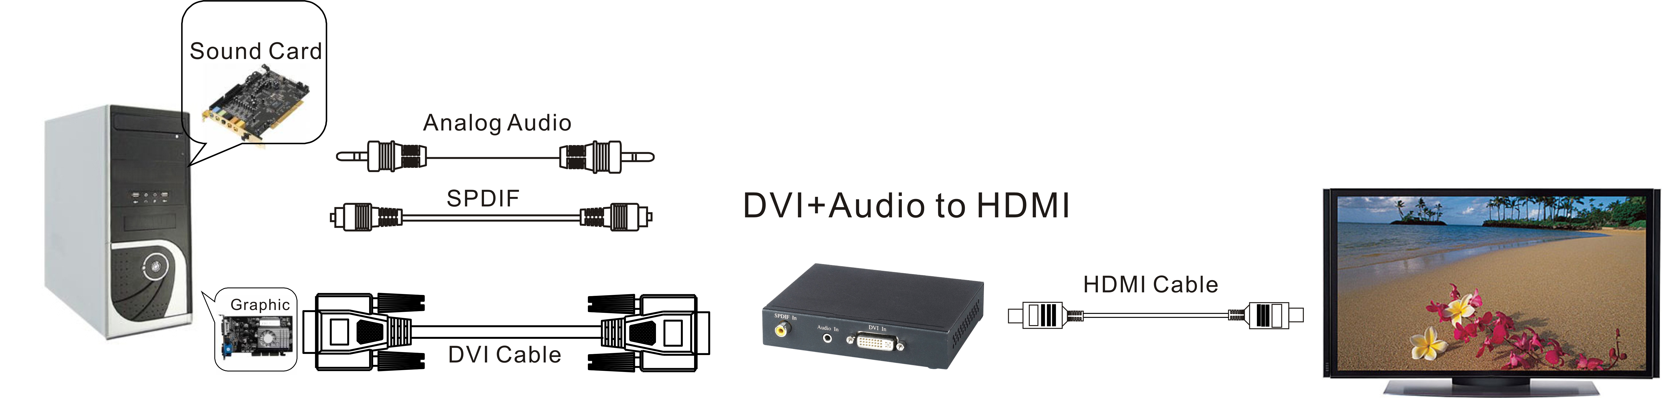

REMARK:
EDID: Extended display identification data is a data structure provided by a computer display to describe its capabilities to a graphics card. It is what enables a modern personal computer to know what kind of monitor is connected

Trouble Shooting:

- If your monitor without audio function, then please setting the rotary switch at 6 (EDID Default), force “audio output” to your external speaker.
- Only HDMI enabled TV sets with underscan/overscan* support, the full active video can be accurately displayed. Some HDMI equipped TV sets may not support this feature. If underscan/overscan* is NOT supported, the top, bottom, left and right border of the active video may be screened, and the S/PDIF audio may not sound right.
- S/PDIF audio input can support up to 8-channel audio input. If your TV not support Dolby Digital or DTS audio decoding, then you will add audio decoder or amplifier.
- S/PDIF supports only 48 KHz audio sample rate. Other than this rate, the input digital audio should be adjusted to 48 KHz in order to get audio signal correctly sent.

Specification:
TEM NO. | HDTVDH01
Video Amplifier Bandwidth | 1.65 Gbps
Output Video Signal | 1.2 Volts p-p
Output DDC Signal | 5 Volts p-p (TTL)
Single Link Rang | 1080P/1920 X 1200
Input/Output Connector | DVI-I 29 pin female (digital only)  HDMI Type A 19 PIN  RCA Connector: Coax SPDIF, Phone Jack: Analog stereo
Temperature | Operation:-10℃~45℃, Storage: -30℃~70℃
Power Consumption | 10 watts (max)
Power Supply | DC5V 2AMP
DIMENSIONS W x H x D mm | 122x95x25
Weight | 300 g

HDTV Supply, Inc.
3835-R East Thousand Oaks Blvd
Unit 295
Westlake Village, CA 91362
(800) 841-9238
(805) 277-1870 Direct
(805) 371-4070 FAX - General

