EDID Learning Instruction for the Cards

1. HDMI Pass-through input card:
Method: Get an HDMI cable to connect with a TV, then press the EDID key twice to read the EDID
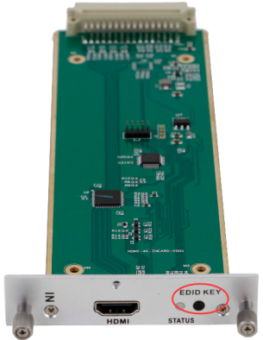
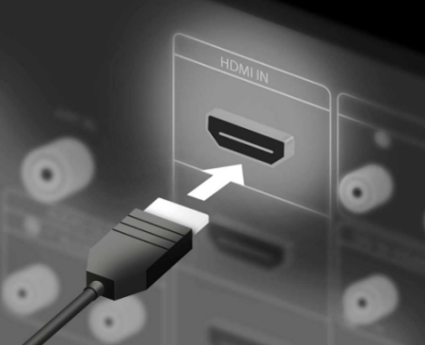
HDMI Cable

- HDBaseT Pass-through input card:
Step 1: Pull the card out, then dial the red DIP switch to 0111 and insert to the chassis.
Step 2: Get an HDMI cable to connect to the TV, and power on.
Step 3: Pull the card out again, and dial the red DIP switch as 0000, and insert to the chassis, and then power on. The EDID have been read successfully.
